**PROJECT REPORT**

**INTRODUCTION:**

1.1  Overview:

Wind energy plays an increasing role in the supply of energy world-wide. The energy output of a wind farm is highly dependent on the wind conditions present at its site. If the output can be predicted more accurately, energy suppliers can coordinate the collaborative production of different energy sources more efficiently to avoid costly overproduction.

              Better prediction models for the upcoming supply of renewable energy are important to decrease the need of controlling energy provided by conventional power plants.

                        Hereby, we formulate the prediction task as regression problem and test different regression techniques such as linear regression, Random Forest and Long short term memory. In our experiments, we analyze predictions for individual turbines and show that a machine learning approach yields feasible results for short-term wind power prediction.

1.2  Purpose:

With the recent and continued increase in wind power, the challenge is clear: how can the energy industry integrate this intermittent power source into the electricity grid?

Traditionally, electricity utilities and system operators have sought to understand the supply side of load balancing with regard to the source of the energy, dispatchability and reserves, as well as the relative cost of producing electricity from non-renewable resources. With wind power increasing as a renewable energy source in many countries, the energy industry will need to adjust its thinking if it is to find an effective way to integrate this intermittent power source into the electricity grid.

And better forecasting will position wind for continued growth and penetration into the global energy mix.

The implications of the value of the forecast are:

* Reduced imbalance charges and penalties;
* Competitive knowledge advantage in real time and ‘day ahead’ energy market trading;
* More efficient project construction, operations, and maintenance planning.

Accurate wind power forecasts are also important in reducing the occurrence or length of curtailments (which translate to cost savings), improved worker safety, and mitigating the physical impacts of extreme weather on wind power systems.

**LITERATURE SURVEY**

2.1  Existing problem

Some of the early works on dynamic modeling and forecasting of wind power generation were cast in a physical deterministic framework. Today however, there is a broad consensus that wind power generation should be modeled as a stochastic process, whatever the spatial and temporal scales involved. A part of uncertainty comes from our lack of knowledge of all the physical processes involved, combined to our limited ability to account for all of them in mathematical and statistical models. There may also be some inherent uncertainty in the data generating process. The choice for appropriate distributions may not be straightforward.

2.2  Proposed solution

We formulate the prediction task as regression problem and test different regression techniques such as linear regression, Random Forest and Long short term memory. In our experiments, we analyze predictions for individual turbines and show that a machine learning approach yields feasible results for short-term wind power prediction.

**Theoritical Analysis:**

3.1 Block Diagram:

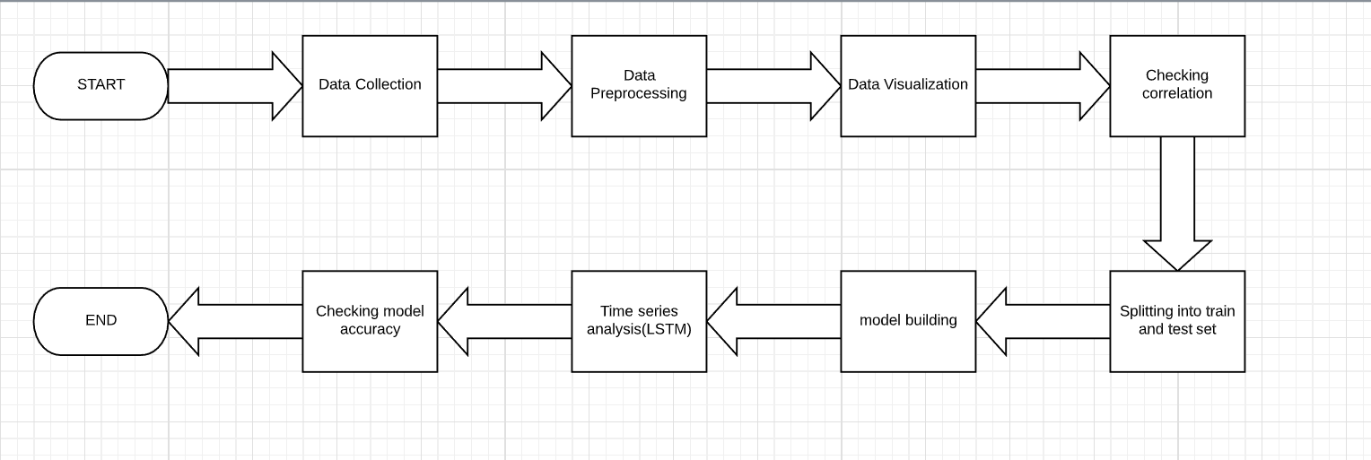

3.2 Hardware And Software Desing:

1) Creating IBM cloud account



2)Creating Watson Studio

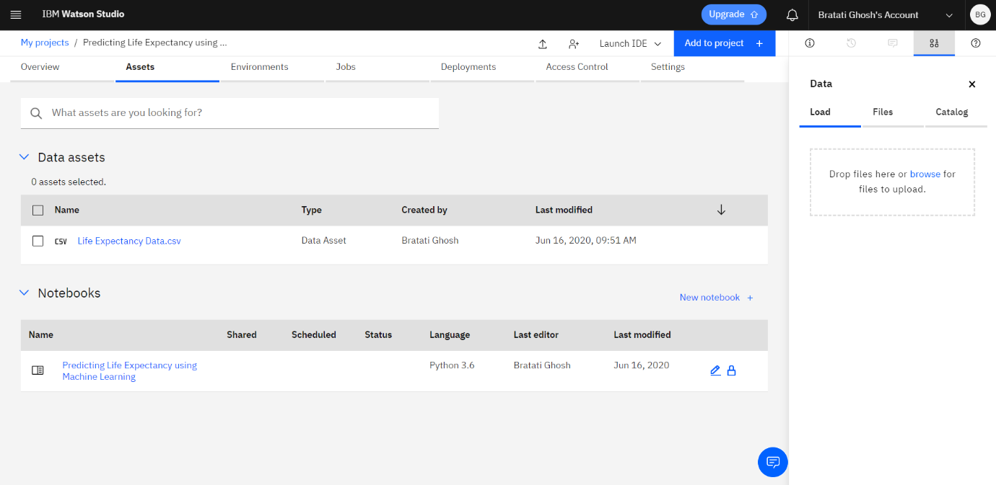

**Experimental Investigation:**

Here, we use LSTM to forecast the future trend of the wind energy.

**Flowchart:**

A **flowchart** is a type of [diagram](https://en.wikipedia.org/wiki/Diagram) that represents a [workflow](https://en.wikipedia.org/wiki/Workflow) or [process](https://en.wikipedia.org/wiki/Process). A flowchart can also be defined as a diagrammatic representation of an [algorithm](https://en.wikipedia.org/wiki/Algorithm), a step-by-step approach to solving a task.

The flowchart shows the steps as boxes of various kinds, and their order by connecting the boxes with arrows. This diagrammatic representation illustrates a solution model to a given [problem](https://en.wikipedia.org/wiki/Problem_solving). Flowcharts are used in analyzing, designing, documenting or managing a process or program in various fields

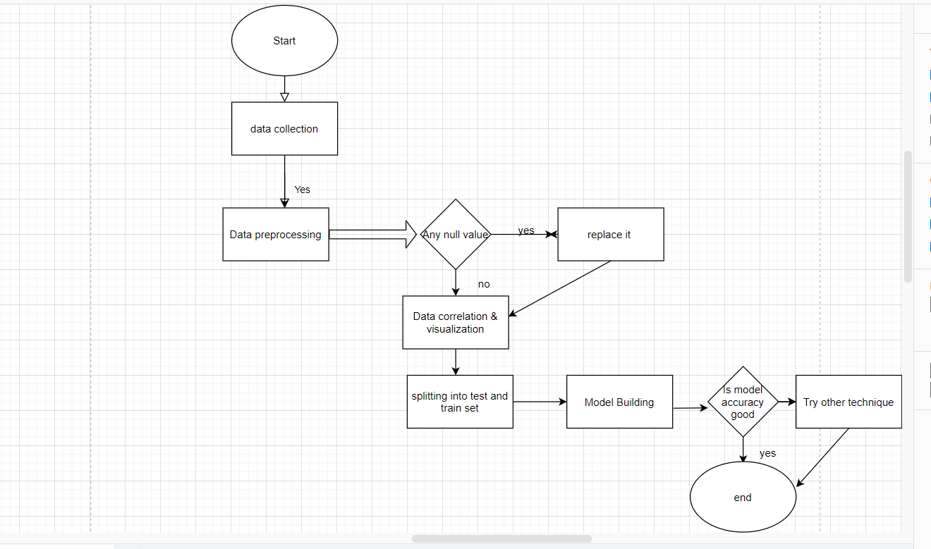

**Result:**

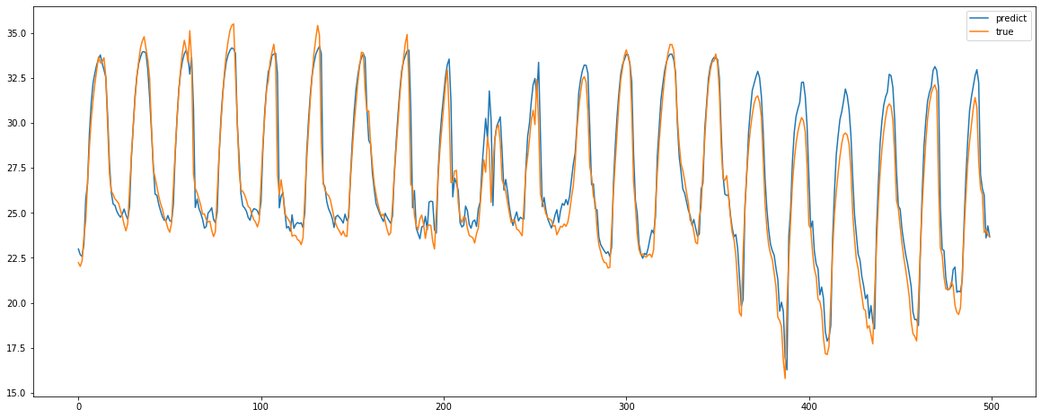

**Advantages of Wind Energy:**

**Clean & Environment friendly Fuel source:**– It doesn’t pollute air like power plant relying on combustion of fossil fuel. It does not produce atmospheric emissions that cause acid rain or green house gases (carbon dioxide (CO2) or methane (CH4)). Noise and visual pollution are both environmental factors, but they don’t have a negative effect on the earth, water table or the quality of the air we breathe.

**Renewable & Sustainable:**– Winds are caused by heating of atmosphere by the sun, earth surface irregularities and the rotation of the earth. For as long as the sun shines the wind blows, the energy produced can be harnessed and It will never run out, unlike the Earth’s fossil fuel reserves.

**Cost Effective:**– Wind energy is completely free. There’s no market for the demand and supply of wind energy’s, It can be used by anyone and is one of the lowest price renewable technologies available today, depending upon the wind resource and the particular project’s financing.

**Industrial and Domestic Installation:**– Wind turbines can be built on existing farms or ranches where most of the best wind sites are found. Wind turbines uses only a fraction of the land which causes no trouble in work for the farmers and rancher, providing landowners with additional income paid by the owners of the wind power plants. Many landowners opt to install smaller, less powerful wind turbines in order to provide part of a domestic electricity supply.

**Job Creation:**– Jobs have been created for the manufacture of wind turbines, the installation and maintenance of wind turbines and also in wind energy consulting. According to the Wind Vision Report, wind has the potential to support more than 600,000 jobs in manufacturing, installation, maintenance, and supporting services by 2050.

**Disadvantages of Wind Energy:**

**Fluctuation of Wind and Good wind sites:**– Wind energy has a drawback that it is not a constant energy source. Although wind energy is sustainable and will never run out, the wind isn’t always blowing. This can cause serious problems for wind turbine developers who will often spend significant time and money investigating whether or not a particular site is suitable for the generation of wind power. For a wind turbine to be efficient, the location where it is built needs to have an adequate supply of wind energy.

**Noise and aesthetic pollution:**– Wind turbines generate noise and visual pollution. A single wind turbine can be heard from hundreds of meters away. Although steps are often taken to site wind turbines away from dwellings. Many people like the look of wind turbines, others do not and see them as a blot on the landscape.

**Not a profitable use of land:**– Alternative uses for the land might be more highly valued than electricity generation.

**Threat to wildlife:**– Birds have been killed by flying into spinning turbine blades. However it is believed that wind turbines pose less of a threat to wildlife than other man made structures such as cell phone masts and radio towers. Most of the problems have been resolved or greatly reduced through technological development or by properly siting wind plants.

**Application of Wind energy:**

1. The wind energy is used to propel the sailboats in river and seas to transport men and materials from one place to another.

2. Wind energy is used to run pumps to draw water from the grounds through wind mills.

3. Wind energy has also been used to run flourmills to grind the grains like wheat and corn into flour.

4. Now-a-days wind energy is being used to generate electricity.

Wind energy may be considered as the world’s fastest growing energy source.

By the development of technology, wind power may become most economical and environmental friendly source of electricity in many countries in the coming 10 to 20 years

**Future Scope:**

Wind energy is available without any cost and it does not emit any greenhouse gases. This makes it a great source of energy production for any developing state. The field of wind energy has tremendous scope for innovation, translating to real world applications and tremendous economic opportunity. It is crucially important for India, as our economy continues to evolve, and we must ensure every Indian has access to opportunity, decent jobs and livelihood. For that we will need greater resources. Clean, sustainable, renewable-and equally important, domestic sources of energy are essential to fulfill the potential of India in the coming years and it is certain that wind energy will play a major part in shaping India's future. Wind power has emerged as the biggest source of renewable energy in the world.

**Conclusion:**

Wind power prediction is a key component in wind power industry which is in high growth rate. Accurate predictions can greatly help in lowering the cost and improving the stability of wind power. Various prediction approaches have been studied in research and applied in practice, among which the machine learning models are currently the most promising ones.

                In this study, we carefully collected the experimental data and ensured that the datasets contain as many wind characteristics as possible. This comprehensive empirical study considered nine models, seven of which are representative machine learning models, namely k-NN, Linear Regression etc. But, to predict wind energy for future we use LSTM ,which gives a quite satisfactory result.

**Bibliography:**

[1] World Footprint: Do we fit on the planet? (2016). Retrieved March 18, 2016, from Global World Footprint website: http://www.footprintnetwork.org/en/index.php/GFN/ [2] Past Earth Overshoot Days. (2015). Retrieved February 15, 2016, from Earth Overshoot Day website: http://www.overshootday.org/newsroom/past-earth-overshoot-days/ [3] This Is A Turning Point: Three Things You Need to Know about The Paris Agreement. (2015, December 12). Retrieved March 4, 2016, from The Climate Reality Project webstie: https://www.climaterealityproject.org/blog/cop21-paris-agreement [4] Fossil Fuel. (2016, March 3). In Wikipedia. Retrieved March 16, 2016, from https://en.wikipedia.org/wiki/Fossil fuel

**Appendix:**

<http://www.sotaventogalicia.com/en/technical-area/real-time-data/historical/>